EXECUTIVE SUMMARY AND KEY POINTS
Terraform as a Service
Banking private cloud · HCP Terraform SaaS control plane
A condensed companion to the full architecture and operating model document. The target architecture, the change control path, who owns what, the regulatory position, the services to be built, the delivery plan and the decisions being requested.
For a reader who will not read forty pages · Detail, full RACI matrices and the complete service inventory are in the main document
About this document
A condensed companion to the full Terraform as a Service architecture and operating model. It carries the architecture, the control path, the ownership model, the regulatory position, the delivery plan and the decisions being requested — in a form a sponsor or a review board can read in fifteen minutes.
The deployment model is HCP Terraform — the HashiCorp-operated SaaS control plane. The bank configures a tenancy and operates execution agents inside its own network; it does not install, patch, back up or recover the control plane. The self-managed Terraform Enterprise option is not carried as an alternative.
Full RACI matrices, the complete service inventory, network flow tables and the detailed risk register are in the main document.
The three things to take from it
- Terraform provisions the service; it does not own it. Platform teams keep accountability for VMware, OpenShift, network, DNS, PKI, storage and backup. The platform team owns the automation and its guardrails.
- The regulatory position is the critical path. State, plan output and run logs describing the private-cloud estate will reside with HashiCorp. That decision belongs to Risk and Compliance, and the assessment is the longest item in the plan.
- Make the sanctioned path better than the manual one before enforcing anything. A platform nobody uses delivers nothing, and a mandate propping one up decays.
Contents
1. Executive Summary
1.1 What is proposed
1.2 What it changes
1.3 What it costs
1.4 Decisions requested
2. The Architecture
2.1 The four layers
2.2 The five points to make in review
3. How a Change Reaches Production
3.1 Why this satisfies change control
4. Operating Model — Who Owns What
4.1 The principle
4.2 Accountability at a glance
4.3 Backup — three domains, three owners
4.4 Disaster recovery — the position to hold
5. The Regulatory Position
5.1 What leaves the bank
5.2 Controls designed in
5.3 Exit position
5.4 The demonstrated controls
6. Services and Delivery Plan
6.1 Services to design and implement
6.2 Phases and gates
6.3 Critical-path dependencies
6.4 Top risks
6.5 What success looks like at twelve months
SECTION 1
Executive Summary
One page. What is proposed, what it changes, and what is being asked for.

1.1 What is proposed
A centrally governed Terraform as a Service capability using HCP Terraform — the HashiCorp-operated SaaS control plane — with runs executing on bank-operated agents inside the bank’s network, provisioning VMware, OpenShift, network, DNS, certificate, backup and storage services in the private cloud.
Development teams consume approved modules through controlled self-service. The platform team owns the automation and its guardrails. The VMware, OpenShift, network, PKI, storage and backup teams continue to own their services — unchanged by the introduction of Terraform.

1.2 What it changes
Outcome | How
Faster provisioning | Self-service against a module catalogue replaces a multi-queue ticket process. Target: an order-of-magnitude reduction in lead time for catalogue items — measured against a baseline captured before build.
Compliant by construction | The compliant configuration is the default configuration. Encryption, tagging, backup registration, DNS and IPAM are applied by the module, not chosen by the consumer.
Controlled change | Every production change carries a reviewed plan, an automated policy result and a named approver — produced by making the change, not written afterwards.
Reduced drift | Scheduled detection makes out-of-band change visible and gives the evidence to reduce standing console access.
Lower platform burden | HashiCorp operates the control plane — roughly one to two FTE less than running it, and no platform upgrade programme.

1.3 What it costs
- A platform team to build and run it — approximately five to six people for roughly eight months to production acceptance, then a standing service team.
- Licence and consumption, which grows with adoption and should be modelled against the projected run volume now rather than at renewal.
- An execution estate — agent hosts across five to six pools, built and maintained as code.
- Engagement from every platform team. Modules are co-owned; a vSphere module written without the VMware team encodes the wrong standards.
- A third-party risk assessment on the critical path — §4 — which is the longest single item in the plan.

1.4 Decisions requested
Decision | From
Accept the regulatory position — that Terraform state, plan output and run logs describing the private-cloud estate reside with HashiCorp, with the controls in §4.3. | Risk, Compliance, Security
Confirm materiality — whether this is a material or critical outsourced arrangement, which changes the governance and timeline. | Compliance
Confirm edition and entitlements in writing — agent pool count, private VCS support, policy engine, audit export, SSO and SCIM. | Procurement with HashiCorp
Approve the operating model — federated ownership, with the platform team owning automation and platform teams owning their services. | Service owner and platform owners
Fund the team and name the service owner, plus a named technical owner per catalogue item. | Sponsor
These gate the start of build.
The one thing to get right: make the sanctioned path genuinely better than the manual one before asking anyone to take it, and before enforcing anything. A technically excellent platform nobody uses delivers nothing, and a mandate used to prop one up decays.
SECTION 2
The Architecture
The target architecture on one page, with the points that matter in review.
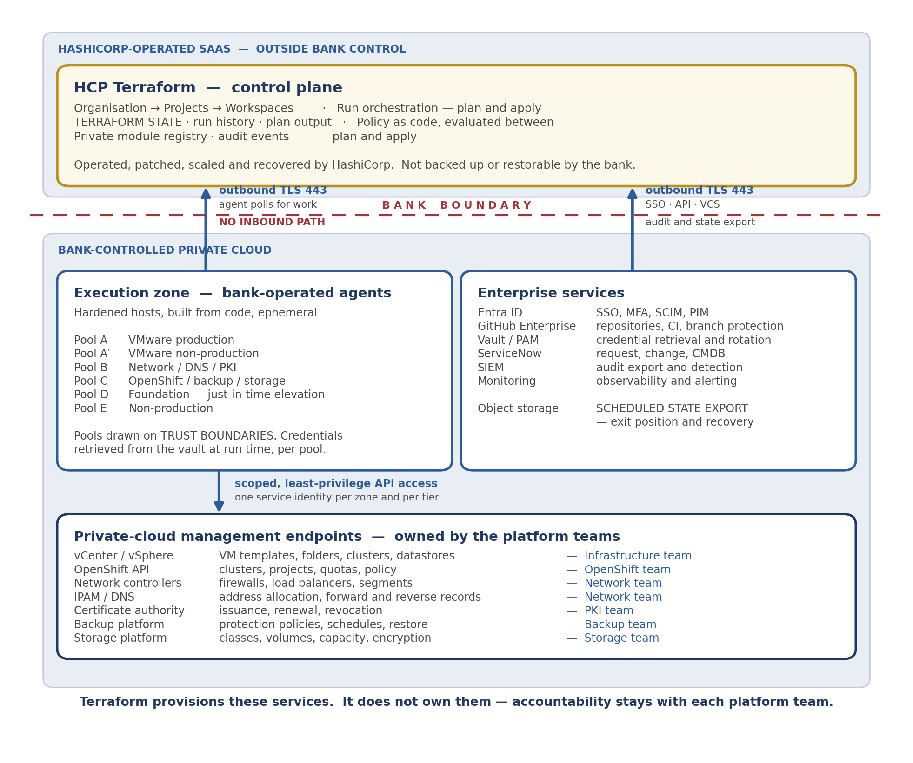

2.1 The four layers
Layer | What it is and who owns it
HCP Terraform | HashiCorp-operated SaaS. Orchestrates runs, holds state and run history, evaluates policy between plan and apply, serves the private module registry. Operated, patched and recovered by HashiCorp — not backed up or restorable by the bank.
Execution zone | Bank-operated agents inside the bank’s network, built from code and ephemeral, organised into pools drawn on trust boundaries. Credentials retrieved from the vault at run time, scoped per pool.
Enterprise services | Entra ID, GitHub Enterprise, Vault, ServiceNow, the SIEM — and bank-controlled object storage holding a scheduled export of state and audit events.
Target platforms | vCenter, OpenShift, network controllers, IPAM and DNS, the certificate authority, backup and storage. Each owned by its existing platform team.

2.2 The five points to make in review
- No inbound path. Agents connect outbound only. Nothing from the SaaS reaches into any protected zone — this is the strongest property of the design and reviewers will assume otherwise unless it is stated.
- Agent pools are an authorisation control, not routing. Production and non-production never share a pool, so a non-production workspace is structurally incapable of obtaining production credentials.
- No credential is stored in the SaaS. Workload identity where the target supports it; vaulted run-time retrieval otherwise. Demonstrated, not asserted — the assurance test is in §5.
- Policy is evaluated inside the platform between plan and apply, at a point a repository owner cannot edit a pipeline to bypass.
- State is exported continuously to bank-controlled storage. This single control serves the exit plan, the recovery position and the evidence requirement at once.
SECTION 3
How a Change Reaches Production
The control path, and the two steps to demonstrate during assurance.
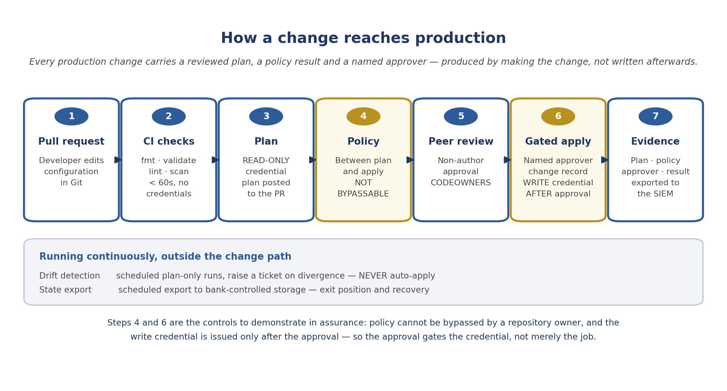

3.1 Why this satisfies change control
Question | Evidence
Who authorised this change? | The pull request — author, reviewers, approval timestamps, and the branch rule in force at the time.
Could the author approve their own change? | Branch protection requires a non-author approval; the production apply requires a named approver from a separate role. Both are exportable configuration.
What exactly changed? | The plan, retained as evidence and exported for the audit retention period.
Was it compliant? | The policy result recorded against the run, with any override and its recorded reason.
Was it tested first? | The same configuration applied to a lower environment, with its own plan and run record.
Can you reproduce the environment? | Yes — that is what the configuration is. An answer most manually-built estates cannot give at all.
What an auditor asks, and what the platform produces automatically.
Agree this with Change Management and Internal Audit early. A large part of the adoption programme is blocked behind accepting that a pull request plus a plan plus a policy result satisfies the existing control objectives. It takes months either way, so it is a document produced *with* them in week one rather than a case argued at them in month six.

SECTION 4
Operating Model — Who Owns What
The five RACI matrices in the full document, condensed. The structural point is federated ownership.

4.1 The principle
Terraform provisions the service; it does not own it. The platform team owns the automation and its guardrails. The infrastructure teams own their services and remain accountable for them whether or not Terraform is the mechanism. The most common operating-model failure in a programme of this shape is the platform team being treated as the owner of everything it automates — the matrices are written specifically to prevent that drift.

4.2 Accountability at a glance
Domain | Accountable | Note
TaaS service outcomes, funding, risk | Service Owner | Including supplier relationship and exit plan.
Tenancy, workspaces, modules, agents, policy implementation | Platform Engineering | The automation and its guardrails — not the services it provisions.
Control plane availability and recovery | HashiCorp | Contractual, not operational. The bank cannot restore it.
Identity, SSO, privileged access, credential rotation | Identity team | Including break-glass custody.
Security requirements, policy content, exception governance | Security | Policy authors are deliberately separate from platform administrators.
Third-party risk, materiality, regulatory position | Risk and Compliance | Gates production acceptance.
VMware, OpenShift, network, DNS, PKI, backup, storage | Each platform team | Unchanged by TaaS. Each owns its own service, API access, capacity and recovery.
Source control, branch protection, CI | GitHub / DevSecOps | Branch protection on manifest repositories is a production control.
Request, change and CMDB processes | Change Management | The service fits the process rather than replacing it.
Monitoring, incident, problem, capacity | Service Operations | For the TaaS capability itself.
Consuming configurations, requirements, testing | Development teams | They own what they build with the modules.
Recovery strategy, RTO/RPO, DR exercises | Business Continuity | Separate targets for orchestration, execution and each target service.
One accountable owner per domain. The full matrices are in the main document, §6 to §10.

4.3 Backup — three domains, three owners
Domain | Owner | Approach
Control plane | HashiCorp | The bank cannot back it up or restore it. What the bank does instead: export state and audit events on a schedule, hold tenancy configuration as code, and rehearse reconstruction.
Execution infrastructure | Platform / Infrastructure | Agents are replaceable. Rebuilt from the pipeline, not restored from VM backup. The non-reproducible items are tokens and certificates, recovered from the vault.
Target infrastructure and data | Each platform team | Each owner defines and operates its own backups. Creating a backup policy through Terraform does not prove a usable backup exists — that distinction must be explicit in every catalogue entry.
Conflating these is the commonest error in a TaaS design.

4.4 Disaster recovery — the position to hold
- A control plane outage is not an infrastructure outage. Running VMs, clusters and network services are unaffected. What is lost is the ability to change them — a different severity and a different response.
- The documented response is to freeze change, not to improvise. Out-of-band changes during an outage are how state and reality diverge, and that divergence outlasts the outage.
- TaaS cannot recover VMware or OpenShift. Each platform recovers under its own DR plan; TaaS resumes managing them afterwards.
- No automatic resumption of applies because connectivity returned. Plan first, review drift, obtain service owner approval, then resume in stages.
- State reconciliation after any restore is a written, rehearsed procedure, not something improvised during recovery.
SECTION 5
The Regulatory Position
The most consequential consideration in this design, and the longest item on the plan.

5.1 What leaves the bank
With a SaaS control plane, Terraform state, plan output, run logs and workspace variables reside with HashiCorp. For a private-cloud estate, state is a detailed and current map of the bank’s infrastructure — hostnames, addresses, network topology, cluster configuration — plus any credential a provider wrote into it.
That may well be acceptable; many regulated institutions place more sensitive data in SaaS. But it must be a decision taken by the risk function with the facts in front of them, and the mitigations presented as part of that decision rather than retrofitted after it. Raising it in the design is considerably better than having it raised in assurance.

5.2 Controls designed in
Control | Effect
Provision permission, not secrets | Terraform creates the vault policy; the workload retrieves the credential at boot. The only control that removes the exposure rather than mitigating it.
No sensitive workspace variables | Where run-time retrieval is possible, use it. The variable persists in the SaaS; the retrieval does not.
Restricted state access | Platform team and audit only. Consuming teams cannot download state.
Deliberate retention | Set to the shorter of the audit requirement and operational need. Five years of plan output held externally is a far larger exposure than ninety days.
Scheduled state export | To bank-controlled encrypted storage — serving exit, recovery and evidence simultaneously.
Audit export with absence alerting | A stopped export is a compliance gap accruing silently.
Workload identity first | For every target that supports it, so no stored credential exists to appear anywhere.
Present these up front as the mitigation set.

5.3 Exit position
- State is extractable through the API and can be reinstated into a different backend. The exit is technically tractable — a materially better position than most SaaS dependencies.
- The configuration already lives in the bank’s Git. Modules, policy and configurations never leave bank control.
- Run history is the part that does not transfer, which is why audit evidence is exported continuously rather than relied on in place.
- Rehearse the extraction on one workspace before go-live — download state, stand it up on a local backend, confirm a no-change plan. A rehearsed exit with a measured timeline is the difference between a credible exit plan and a paragraph, and it takes an afternoon.

5.4 The demonstrated controls
Demonstrate these during assurance rather than describing them. Several verify a control by confirming something correctly fails, which is more convincing than observing the success path.
- A mis-scoped run is refused — a workspace cannot execute on a pool it is not scoped to.
- A non-production credential cannot perform a production action — the quarterly assurance test. If it succeeds, the credential model is not designed, regardless of how the permission matrix looks.
- A consuming team member cannot download state.
- An application-team member cannot apply to production.
- A deliberate policy violation is blocked between plan and apply.
- The audit export absence alert fires when the export is stopped.
- A recovery and state reconciliation, performed by someone other than the runbook author, with the time recorded.
SECTION 6
Services and Delivery Plan
What will be built, in what order, and what has to come from other teams.

6.1 Services to design and implement
Group | Services
Core platform | Tenancy administration · execution service and agent pools · execution zone design · runtime and version management · workspace lifecycle · private module registry · module release gate · policy as code · credential service · drift detection · observability · supplier management.
Infrastructure catalogue | VMware foundation · virtual machine provisioning with IPAM, DNS, backup and monitoring integrated · guest configuration hand-off · OpenShift cluster and project provisioning · network services · DNS and IPAM · certificate management · backup services · storage services · monitoring onboarding · decommissioning.
Identity and security | Workforce identity · privileged identity · service-to-service authentication · source control governance · secure pipeline · policy enforcement · change management · compliance and audit · state and data protection · software supply chain.
Service management | Service catalogue · self-service request fulfilment · incident · problem · change and release · CMDB · capacity · vulnerability management · observability · knowledge and enablement · DR · financial management.
Each line is a workstream with an owner, a service definition and acceptance criteria. The full inventory is in §11 of the main document.
The highest-value items are the VM and OpenShift project entries, and specifically what is inside them. The vSphere resource is the easy part — the value is that the module also allocates the IP, creates both DNS records, assigns the backup policy and registers monitoring, which is the ten-step process that today involves emailing four teams.

6.2 Phases and gates
Phase | Weeks | Delivers | Gate
P0 | 1–6 | Mobilise. Start the risk assessment and data classification. Confirm entitlements. Raise every dependency. Capture the lead-time baseline. Name the pilot team and the future platform owner. | G0 Decision
P1 | 5–9 | Tenancy, Entra SSO enforced, RBAC from directory groups, break-glass, audit export. | G1 Foundation
P2 | 8–13 | Agent image and pools per zone and tier. Network flows. Provider mirror. | G2 Execution
P3 | 11–16 | Run-time credentials per target. The assurance test passed. | G3 Credentials
P4 | 14–20 | 3–5 golden modules through the release gate. Standards published. Policy advisory. | G4 Paved road
P5 | 18–24 | Pilot: one team live end to end, self-sufficient. Before-and-after figures published. | G5 Pilot
P6 | 22–28 | Agent loss, outage runbook, state recovery and reconciliation tested. | G6 Resilience
P7 | 26–32 | Security assurance. Service definition. Operational handover. Named owner in post. | G7 Production
Indicative for a core team of five to six. Phases overlap; the gates do not.
The sequencing is deliberate: capability first, adoption second, enforcement last. Enforcing policy before the paved road is good produces malicious compliance and forked modules — and recovering the mandate is much harder than fixing any technical problem.

6.3 Critical-path dependencies
Dependency | Owner | Lead time | Blocks
Third-party / outsourcing assessment | Risk, Vendor Mgmt | 8–16 weeks | Production acceptance. The longest and least compressible item.
Control mapping with Change and Audit | Change, Internal Audit | 8–16 weeks | Scale. **A document produced *with* them, not argued at them.**
Data classification for state and plans | Security | 4–8 weeks | The regulatory position and the control set.
Vault safes and application identities | Identity, PAM | 4–8 weeks | G3. Least predictable technical dependency.
Entra app registration and group creation | Identity | 3–6 weeks | G1. Request groups in one batch.
Edition, licensing and entitlements | Procurement | 4–8 weeks | Several design assumptions.
Provider and module mirror | Software distribution | 3–5 weeks | On the path of every run. Tier-one dependency, not a cache.
Network flows and firewall rules | Network | 3–6 weeks | G2. Short list — agents are outbound only.
Service accounts per target platform | Each platform owner | 3–6 weeks | G3. Six requests — raise together with roles agreed.
IPAM delegation and DNS update rights | Network | 4–8 weeks | G4. An ownership conversation, not a ticket.
Tag-driven backup and monitoring discovery | Backup, Operations | 4–8 weeks | G4. Organisational, not technical — start early.
**Raise all of these in week one, in parallel.** Most programmes of this shape are delayed by a safe or an assessment, not by engineering.

6.4 Top risks
Risk | Mitigation and early warning
The regulatory position is not approved, or approved with conditions the design cannot meet. | Start the assessment in week one with the §5.2 controls already designed in. Secure a conditional position early. Warning: assessment not started by week three.
Dependency delay — safes, groups, flows or the mirror. | All raised week one, named contact per team, weekly review with the sponsor. Warning: a dependency with no named owner after week two.
Adoption fails — the platform is built and teams provision manually. | Pilot early with published figures; catalogue before mandate; enablement resourced. Warning: the pilot team still needs help with routine changes after week four.
The platform team becomes a request queue. | Templated self-service onboarding, federated module maintenance, a published service definition stating what is not provided. Warning: rising tickets for routine provisioning.
Credential model compromise — a shared account with estate-wide rights. | The G3 assurance test, repeated quarterly. Warning: "just use the existing service account to unblock testing".
No named platform owner, and the capability degrades after build. | Name in month one; escalate if not possible; build fewer, simpler things if unresolved. Warning: the question deferred twice.
Platform teams do not engage, so modules encode the wrong standards. | Modules are co-owned. Named technical owner per catalogue item before build starts.

6.5 What success looks like at twelve months
- Provisioning lead time for catalogue items reduced by an order of magnitude, measured against the baseline captured before build.
- A named proportion of new provisioning going through the service, rising monthly.
- A rising first-time policy pass rate — the best single indicator that policy, modules and understanding agree.
- Teams onboarding themselves in a working day, without platform-team involvement.
- Policy enforcing rather than advisory, with override usage near zero.
- Drift events falling, and standing console access reduced on the evidence.
- A rehearsed recovery and a rehearsed exit, both with measured times.
- A named platform owner operating the service, with the build team dispersed.

